**Week 4 Homework Submission File: Linux Systems Administration**

**Step 1: Ensure/Double Check Permissions on Sensitive Files**

1. Permissions on `/etc/shadow` should allow only `root` read and write access.

- Command to inspect permissions: ls -l /etc/shadowls

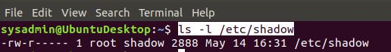

- Command to set permissions (if needed): sudo chmod 600 /etc/shadow

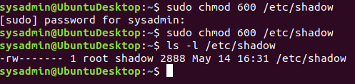

2. Permissions on `/etc/gshadow` should allow only `root` read and write access.

- Command to inspect permissions: ls -l /etc/gshadow

- Command to set permissions (if needed): sudo chmod 600 /etc/gshadow



3. Permissions on `/etc/group` should allow `root` read and write access, and allow everyone else read access only.

- Command to inspect permissions: ls -l /etc/group



- Command to set permissions (if needed): sudo chmod 644 /etc/group (Not Required)

4. Permissions on `/etc/passwd` should allow `root` read and write access, and allow everyone else read access only.

- Command to inspect permissions: ls -l /etc/passwd



- Command to set permissions (if needed): sudo chmod 644 /etc/passwd (Not Required)

**Step 2: Create User Accounts**

1. Add user accounts for `sam`, `joe`, `amy`, `sara`, and `admin`.

- Command to add each user account (include all five users):

sudo useradd sam

sudo useradd joe

sudo useradd amy

sudo useradd sara

sudo useradd admin

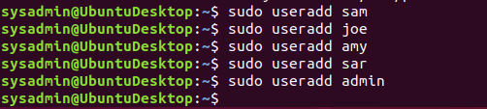

2. Ensure that only the `admin` has general sudo access.

- Command to add `admin` to the `sudo` group: sudo usermod -aG sudo admin

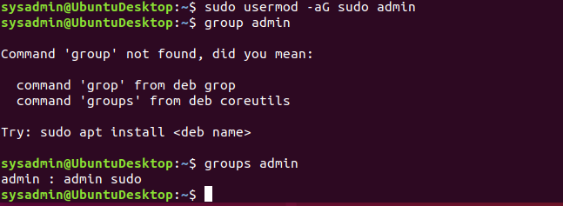

**Step 3: Create User Group and Collaborative Folder**

1. Add an `engineers` group to the system.

- Command to add group: sudo groupadd engineers



2. Add users `sam`, `joe`, `amy`, and `sara` to the managed group.

- Command to add users to `engineers` group (include all four users):

sudo usermod -aG engineers sam

sudo usermod -aG engineers joe

sudo usermod -aG engineers amy

sudo usermod -aG engineers sara

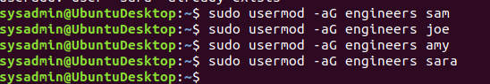

3. Create a shared folder for this group at `/home/engineers`.

- Command to create the shared folder: sudo mkdir /home/engineers



4. Change ownership on the new engineers' shared folder to the `engineers` group.

- Command to change ownership of engineer's shared folder to engineer group:

sudo chown -R :engineers /home/engineers



**Step 4: Lynis Auditing**

1. Command to install Lynis: sudo apt install lynis

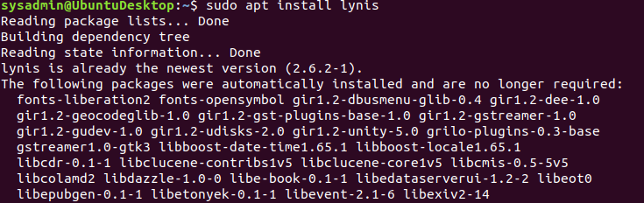

2. Command to see documentation and instructions: man lynis



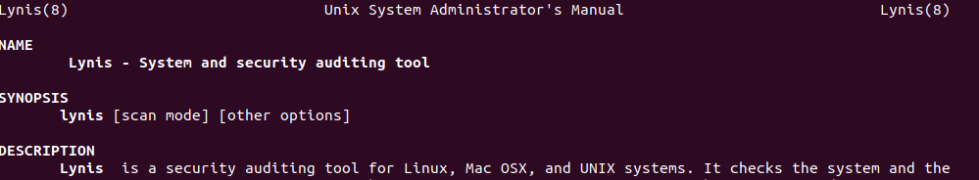

3. Command to run an audit: sudo lynis audit system

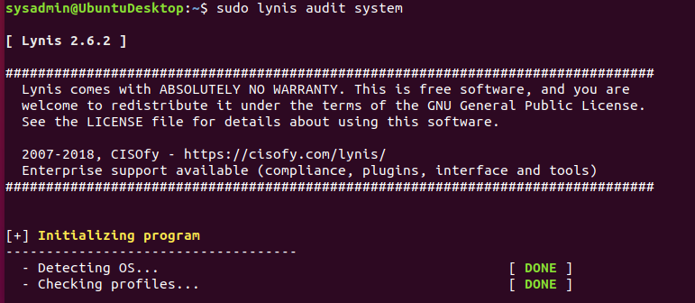

4. Provide a report from the Lynis output on what can be done to harden the system.

- Screenshot of report output:

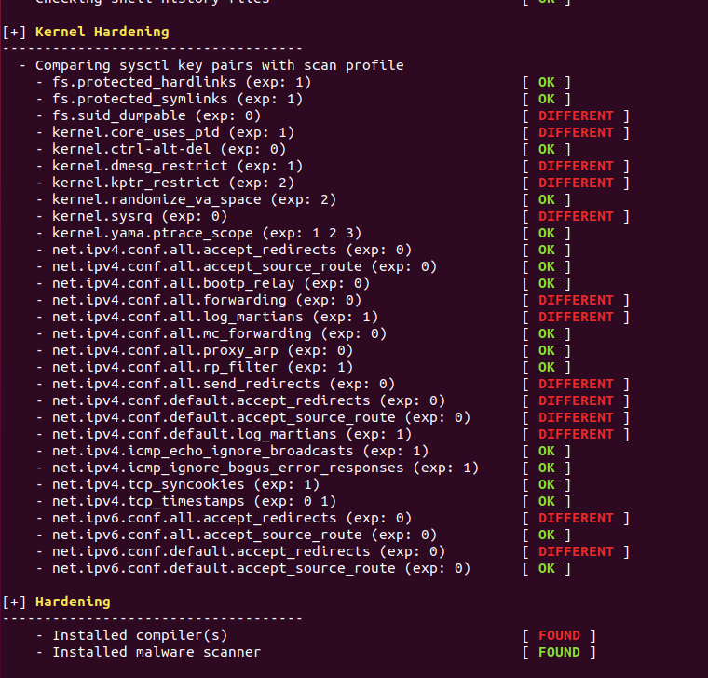

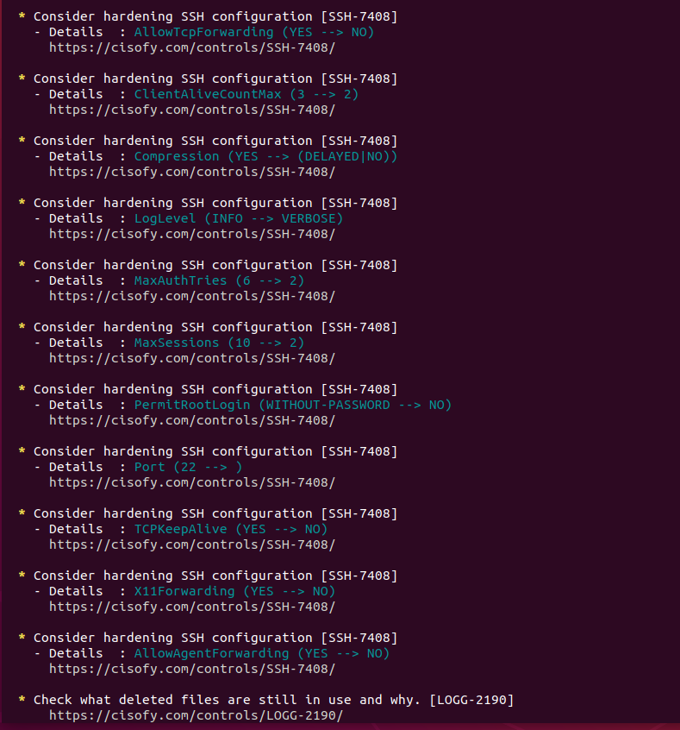

**Bonus**

1. Command to install chkrootkit: sudo apt install chkrootkit

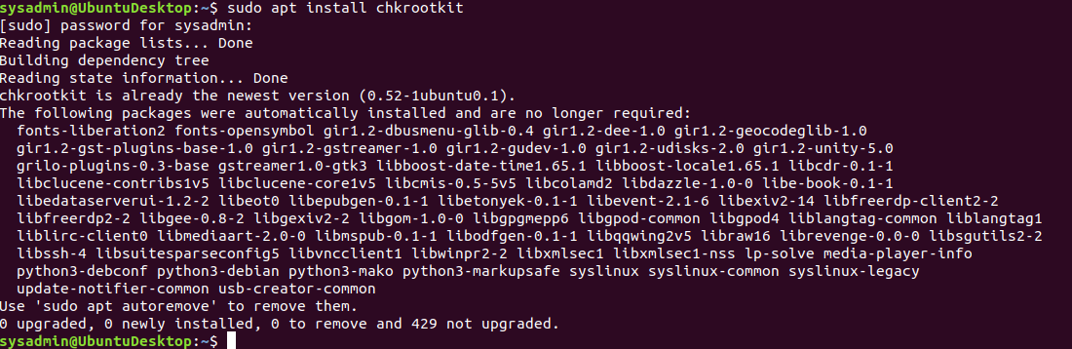

2. Command to see documentation and instructions: man chkrootkit



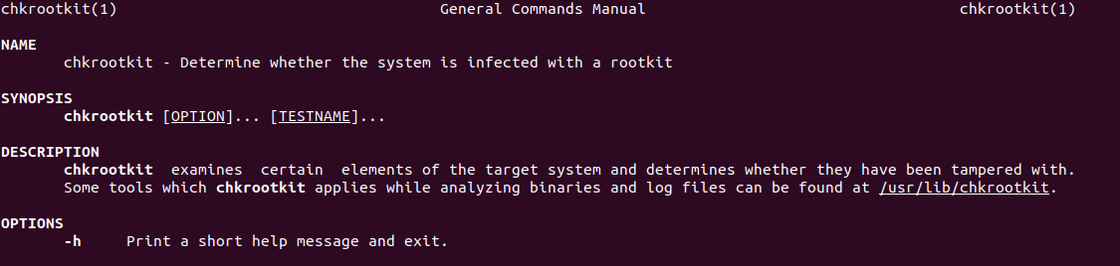

3. Command to run expert mode: sudo chkrootkit -x



4. Provide a report from the chrootkit output on what can be done to harden the system.

- Screenshot of end of sample output:

